Example1





Example2





Example3

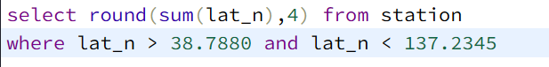

Example4

